2014 Annual Report to
the School Community

  Wodonga Middle Years College
  School Number: 8851
 |  | 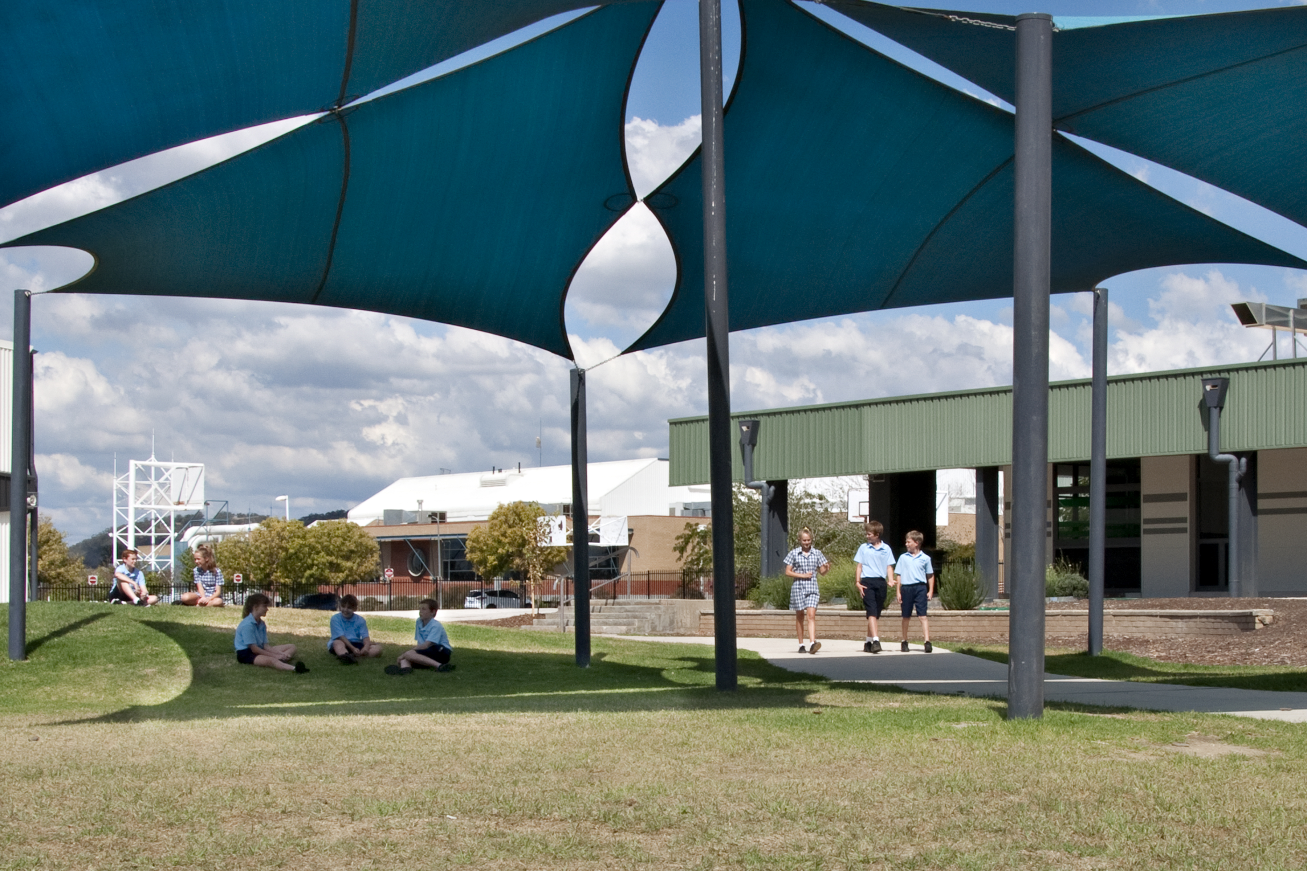 | 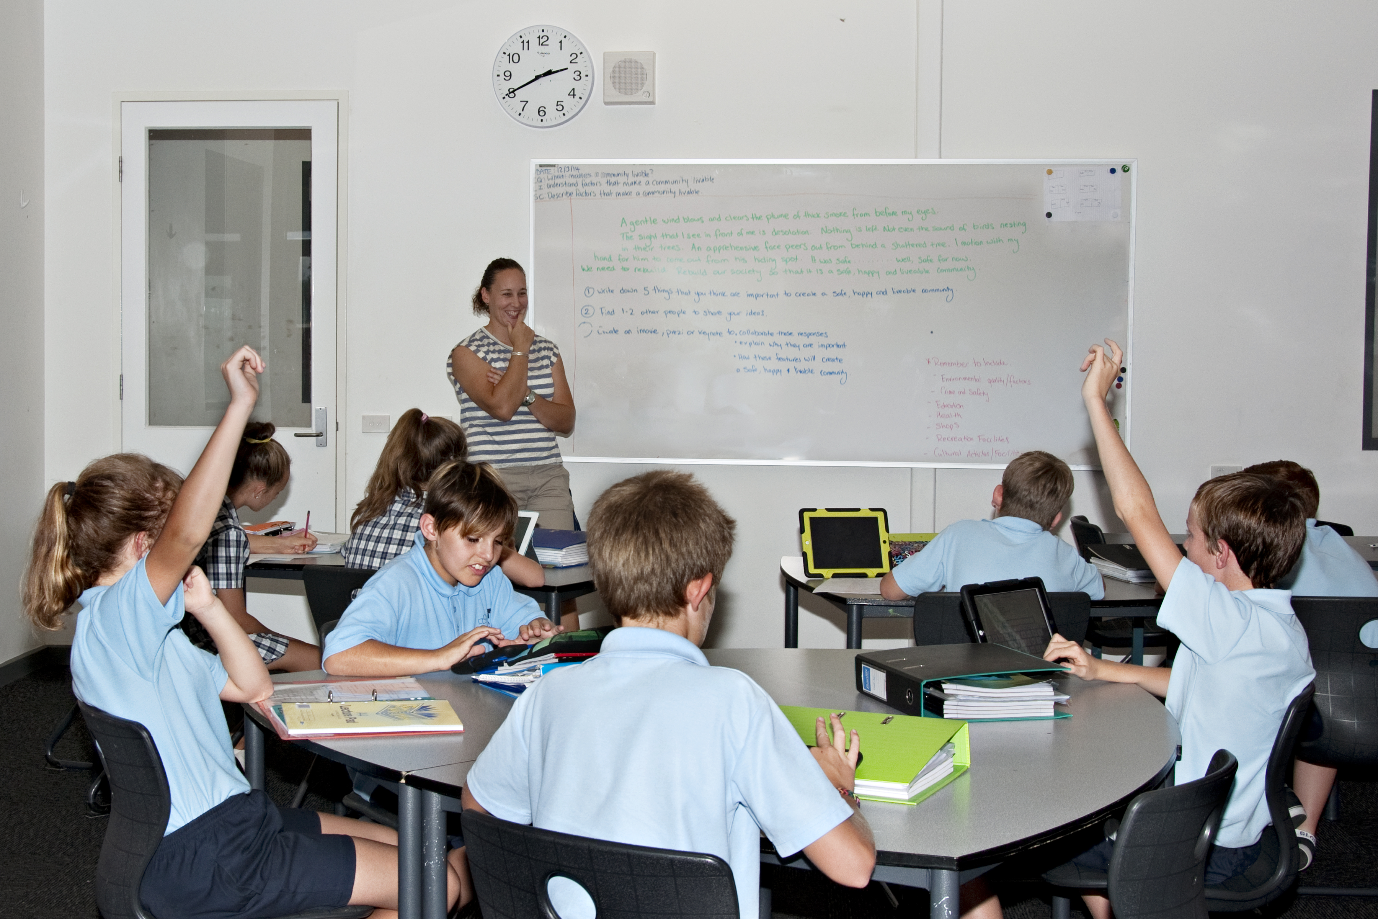
  Russell Polson
  Name of School Principal:
 |  |  |  | Sharyn Ryan
 |  |  |  | Sharyn Ryan
  Name of School Council President:
 |  |  |  | 27th April, 2015
  Date of Endorsement:

All Victorian government school teachers meet the registration requirements of the Victorian Institute of Teaching (www.vit.vic.edu.au).

This school meets prescribed minimum standards for registration as regulated by the Victorian Registration and Qualifications Authority (VRQA) in accordance with the Education and Training Reform Act 2006, inclusive of those schools granted an exemption by the VRQA under the 'Student enrolment numbers' and/or 'Curriculum framework for schools - languages program' minimum standards until 31 December 2014.

About Our School

School Context

A multi campus co-educational College catering for students in Years 7 – 9; Wodonga Middle Years College is pivotal to the delivery of Middle Years education in the Victorian Government Education system. In 2014, the school had 101.86 eft staff. 5.94 principal class, 69.28 teachers and 26.64 support staff. The enrolment was 923, 472 female and 451 male. 22
students are funded through PSD. The SFO was .6476 at Huon, .613 at Felltimber and .3682 at the FFFCS.

Our Vision - Government secondary schools in Wodonga are student focused learning communities. Our graduates
will display confidence, be optimistic about their future and be committed to personal achievement and global
citizenship.

Our Mission - To be a student focused learning community from which our graduates will:
• Be confident, capable and self-motivated.
• Be comfortable living in a world of diverse people, cultures, and beliefs.
• Be able to establish and maintain effective relationships.
• Be tolerant and act with empathy.
• Be respectful of self and others.
• Make meaningful contributions to society – the local and global community.
• Demonstrates intellectual tenacity and persistence in problem solving
• Be skilled analytic, critical, aesthetic and creative thinkers as the situation demands.
• Respond positively and appropriately to change and challenges.
• Set high expectations for themselves and act to meet those expectations.
• Flourish in a digital world and be a skilled user of evolving technologies.
• Be aware of post school options and successfully access them.

WMYC provides educational experiences specifically designed to meet every student's diverse social, emotional
and intellectual needs. The college offers a range of programs to meet students’ diverse learning needs. The SEAL, Literacy and Numeracy Intervention, Highwater Theatre, Flying Fruit Fly Circus School and Flexible Learning Centre and Achievement Via Individual Determination (AVID) .

All students have an Advocate teacher and Restorative Practices along with School wide Positive Behaviour Support (SWPBS) underpin our student wellbeing practices. The College is on its way to becoming eSmart.

Achievement

Professional Learning Communities have focused on the three layers of Curriculum Documentation - Curriculum Maps, Understanding by Design Unit plans and Best Practice Lesson Plans, as well as Common Formative and Summative Assessment.

iPads and application were successfully introduced and implemented at Year 8 and continue to be refined.

The 2014 NAPLAN Year 5 (FFFCS) results indicate performance similar that of similar schools in Reading and Numeracy. The Year 9 results indicate performance similar that of similar schools in Numeracy and Reading.

An Evidence into Action team gathered data on Visible Learning to guide and develop an Action plan to be implemented in 2015.

Student Led Conferences were successfully introduced and are an integral component of our reporting system.

GPA was implemented in which there are now 6 cycles of reporting and feedback to students and families.

Academic Intervention was implemented to support students at risk with their learning.

All 22 Program for Students with Disability students were provided with extensive support such as tutoring, in class support, alternative programs and their goals were regularly reviewed and reflected on an Individual Learning Plan.

Learning Management System (LMS), common and consistent pedagogy, Visible Learning and working with WSSC to develop a Guaranteed and Viable Curriculum will be foci for 2015.

Engagement

Student attendance processes are continually reflected on and therefore improved. A new Attendance Plan along with regular SSG meetings support students with non attendance.

Catering for student individual differences through programs such as High Water Theatre, Flying Fruit Fly Circus School and the Flexible Learning Centre increased the diversity of options for all middle years students.

We continue to develop effective partnerships with community agencies and other education providers so as to support the College community

My Aspiration Plans (MAPs) were introduced and implemented and support students with setting and achieving their learning goals and to also build a vision of achievement and success at school.

Learning programs are differentiated and include formalised assessment and feedback to ensure students’ needs are catered for.

Trialing new aspects of First Class to monitor student attendance as well as the implementation of a 'Hands on Learning Program' are the focuses for 2015.

Wellbeing

Our school values - Care for relationships, Achievement, Persistence and Service (C.A.P.S) continue to build a positive, safe and orderly learning environments within the College.

The Values Matrix was updated in Term 4 2013 and implemented and displayed across the College in 2014 and 2015.

Student management processes and documents were updated. This ensures a common and consistent approach across the College.

Developing a common and consistent approach to CAPS and Explicit Teaching Program of the values are the focuses for 2015.

Student support includes structured year level teams with student advocacy, a wellbeing team with case managers, chaplains and Defence force Liaison on each campus. The college operates School wide Positive Behaviour Support underpinned with Restorative Practices.

Productivity

Wodonga Middle Years College uses resources provided to support improved student outcomes and achieve the goals and targets as set out in the school Annual Implementation plan. Teams are organised in Year Levels with teachers generally teaching in one Year Level. Year Levels have their own designated facilities including, classrooms, offices and, where possible, toilets. These facilities ensure that staff and students have ownership over the facilities. A part of this ownership is displaying posters and student work that directly relate to Visible Learning, Numeracy and Literacy Intervention, Advancement Via Individual Determination (AVID) including WICOR strategies, School Wide Positive Behaviour Support (SWPBS), eLearning and eSmart and Academic Vocabulary.
The College encourages outside organisations to use the school facilities so they are used as much as possible. Futsal, Wodonga Raiders Football Club, a private music tutor, a local theatre company, Victorian School of Languages, Volleyball association, Carevan, community garden and a joint lease of the Wodonga Sports and leisure centre are some partnerships with the local community. Many of these partnerships lend themselves to using local expertise in many areas of the school program.
Professional Learning in the College is generally based on the local expert model. Few staff go outside to the school for Professional Learning, those that do are expected to return to school and share this learning with other staff through Professional Learning Communities.
The timetable is always planned around core classes of 25 students and practical classes (Technology) of 23 where possible. A literacy class of no more than 16 students is always planned for at Years 7 and 8.
A full time teacher teaches approximately 1090 minutes per week. Teachers also do an extra per fortnight and 3 under allotted periods per fortnight. When a staff member is not taking an under allotted at their allocated time they take on the responsibility of academic intervention with particular a particular student or students. Staff will be teaching a total of 1172 minutes per week. Teaching staff are 28 minutes under allotted. It is expected in this time that they are liaising with parents to complete student My Aspiration Plans (MAPs) and Individual Education Plans (IEPs).
Under-allotted teachers will be given replacement classes up to a full time teaching allocation. Wherever possible, these will be allocated before extras and could consist of team-teaching, special programs or other duties by agreement.
At Wodonga Middle Years College, teachers in their first 12 months of teaching who commence at the start of the school will teach a full allotment but will not have an A-Team.
First year teachers who commence in the course of the year will receive a 5% workload reduction by agreement. This may take the form of a whole day CRT replacement at 6 weekly intervals or time release through other mechanisms.
Funds sought from outside to support school initiatives, Sunshine foundation and various smaller grants.

For more detailed information regarding our school please visit our website at
http://www

(Primary Year Levels)
  Performance Summary
The Government School Performance Summary provides an overview of how this school is performing and how it compares to all other Victorian government schools.

All schools work in partnership with their school community to improve outcomes for children and young people. Sharing this information with parents and the wider school community will foster engagement and collaboration to support further gains and positive learning experiences for all students.

School Profile

School Enrolments

A total of 923 students were enrolled at this school in 2014, 472 female and 451 male.

  Overall socio-economic profile
  Based on the school's Student Family Occupation index which takes into account parents' occupations.
  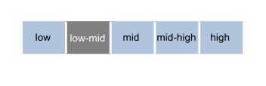
Proportion of students with English as a second language.

  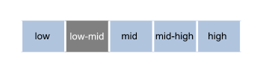
Parent Satisfaction Summary

Average level of parent satisfaction with the school, as derived from the annual Parent Opinion survey. The score is reported on a scale of 1 to 7, where 7 is the highest possible score.

  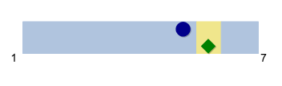
School Staff Survey

Measures the percent endorsement by staff on school climate derived from the annual School Staff survey. The percent endorsement indicates the percent of positive responses (agree or strongly agree) on school climate from staff at the school.
Data are suppressed for schools with fewer than three respondents to the survey for confidentiality reasons.

  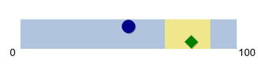

  (Primary Year Levels)
  Performance Summary
  Achievement
  Student Outcomes
  School Comparison
  Teacher assessments from the Australian Curriculum/Victorian Essential Learning Standards (AusVELS)
  Percentage of students in Years Prep to 6 with a grade of C or above in:
  • English
  • Mathematics
  The grades are the same as those used in your child's end of year report.
  A 'C' rating means that a student is at the standard expected at the time of reporting.
  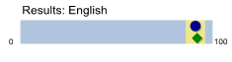
  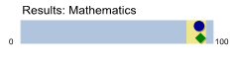
  
  



NAPLAN Year 3

Average score achieved on the NAPLAN Reading and Numeracy tests conducted in May each year.

Year 3 assessments are reported on a scale from Bands 1-6.

Bands represent different levels of achievement. For Year 3, the National Minimum Standard is at Band 2.

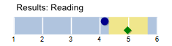
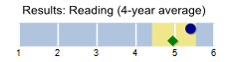
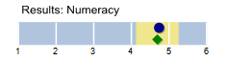
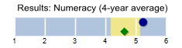

NAPLAN Year 5

Average score achieved on the NAPLAN Reading and Numeracy tests conducted in May each year.

Year 5 assessments are reported on a scale from Bands 3-8.

Bands represent different levels of achievement. For Year 5, the National Minimum Standard is at Band 4.

  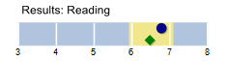
  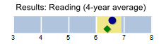
  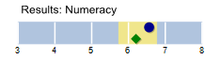
  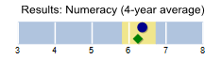
  

  (Primary Year Levels)
  Performance Summary
  Achievement
  Student Outcomes
  School Comparison
  
  
  
  
  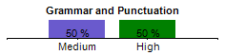
  NAPLAN Learning Gain does not require a School Comparison.
NAPLAN Learning Gain
Year 3 - Year 5

Learning gain of students from Year 3 to Year 5 in the following domains; Reading, Numeracy, Writing, Spelling and Grammar and Punctuation.

NAPLAN learning gain is determined by comparing a student's current year result to the results of all ‘similar’ Victorian students (i.e. students in all sectors in the same year level who had the same score two years prior). If the current year result is in the top 25%, their gain level is categorised as ‘High’, middle 50%, is ‘Medium’ and bottom 25%, is ‘Low’.

  (Primary Year Levels)
  Performance Summary
  Engagement
  Student Outcomes
  School Comparison
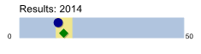
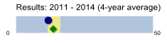
Prep | Yr1 | Yr2 | Yr3 | Yr4 | Yr5 | Yr6
NA | NA | NA | 94 % | 95 % | 93 % | 93 %

  Student Attendance
  Average days absent per full time equivalent (FTE) student per year. Common reasons for non-attendance include illness and extended family holidays.
  Absence from school can impact on students’ learning. A school comparison rating of ‘lower’ indicates that the absence rate in this school is greater than what we would estimate, given the background characteristics of their students.
  Average 2014 attendance rate by year level:
  

  (Primary Year Levels)
  Performance Summary
  Wellbeing
  Student Outcomes
  School Comparison
  Students Attitudes to School
  Measures the Connectedness to School factor derived from the Attitudes to School survey completed annually by Victorian government school students in Years 5 to 12. The school's average score is reported here on a scale of 1 to 5, where 5 is the highest possible score.
  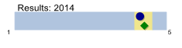
  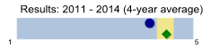
  

(Secondary Year Levels)
  Performance Summary
The Government School Performance Summary provides an overview of how this school is performing and how it compares to all other Victorian government schools.

All schools work in partnership with their school community to improve outcomes for children and young people. Sharing this information with parents and the wider school community will foster engagement and collaboration to support further gains and positive learning experiences for all students.

School Profile

School Enrolments

A total of 923 students were enrolled at this school in 2014, 472 female and 451 male.

Overall socio-economic profile

Based on the school's Student Family Occupation index which takes into account parents' occupations.

Proportion of students with English as a second language.

Parent Satisfaction Summary

Average level of parent satisfaction with the school, as derived from the annual Parent Opinion survey. The score is reported on a scale of 1 to 7, where 7 is the highest possible score.

  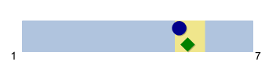
School Staff Survey

Measures the percent endorsement by staff on school climate derived from the annual School Staff survey. The percent endorsement indicates the percent of positive responses (agree or strongly agree) on school climate from staff at the school.
Data are suppressed for schools with fewer than three respondents to the survey for confidentiality reasons.

  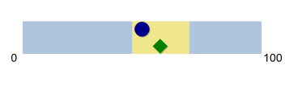

  (Secondary Year Levels)
  Performance Summary
  Achievement
  Student Outcomes
  School Comparison
  Teacher assessments from the Australian Curriculum/Victorian Essential Learning Standards (AusVELS)
  Percentage of students in Years 7 to 10 with a grade of C or above in:
  • English
  • Mathematics
  The grades are the same as those used in your child's end of year report.
  A 'C' rating means that a student is at the standard expected at the time of reporting.
  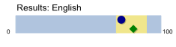
  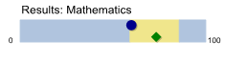
  NAPLAN Year 7
  Average score achieved on the NAPLAN Reading and Numeracy tests conducted in May each year.
  Year 7 assessments are reported on a scale from Bands 4-9.
  Bands represent different levels of achievement. For Year 7, the National Minimum Standard is at Band 5.
  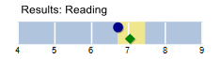
  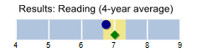
  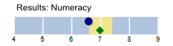
  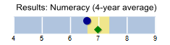
  Being the first year of secondary school, Year 7 NAPLAN is not used for the School Comparison.
  NAPLAN Year 9
  Average score achieved on the NAPLAN Reading and Numeracy tests conducted in May each year.
  Year 9 assessments are reported on a scale from Bands 5-10.
  Bands represent different levels of achievement. For Year 9, the National Minimum Standard is at Band 6.
  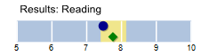
  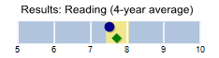
  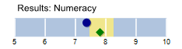
  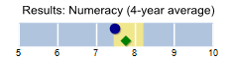

  (Secondary Year Levels)
  Performance Summary
  Achievement
  Student Outcomes
  School Comparison
  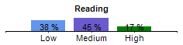
  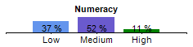
  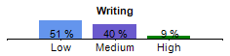
  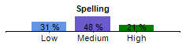
  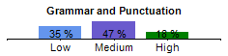
  NAPLAN Learning Gain does not require a School Comparison.
NAPLAN Learning Gain
Year 5 - Year 7

Learning gain of students from Year 5 to Year 7 in the following domains; Reading, Numeracy, Writing, Spelling & Grammar and Punctuation.

NAPLAN learning gain is determined by comparing a student's current year result to the results of all ‘similar’ Victorian students (i.e. students in all sectors in the same year level who had the same score two years prior). If the current year result is in the top 25%, their gain level is categorised as ‘High’, middle 50%, is ‘Medium’ and bottom 25%, is ‘Low’.

  NAPLAN Learning Gain
  Year 7 - Year 9
  Learning gain of students from Year 7 to Year 9 in the following domains; Reading, Numeracy, Writing, Spelling & Grammar and Punctuation.
  NAPLAN learning gain is determined by comparing a student's current year result to the results of all ‘similar’ Victorian students (i.e. students in all sectors in the same year level who had the same score two years prior). If the current year result is in the top 25%, their gain level is categorised as ‘High’, middle 50%, is ‘Medium’ and bottom 25%, is ‘Low’.
  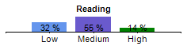
  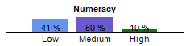
  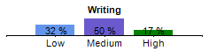
  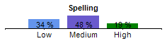
  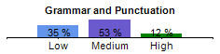
  NAPLAN Learning Gain does not require a School Comparison.
  Victorian Certificate of Education (VCE)
  Mean study score from all VCE subjects undertaken by students at this school.
  This includes all Unit 3 and 4 studies (including those completed in Year 11) and any VCE VET studies awarded a study score. The maximum student study score is 50 and the state-wide mean (including government and non-government schools) is set at 30.
  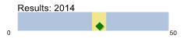
  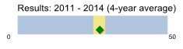
Students in 2014 who satisfactorily completed their VCE: 0%
Year 12 students in 2014 undertaking at least one Vocational Education and Training (VET) unit of competence: 0%
VET units of competence satisfactorily completed in 2014: 0%
Victorian Certificate of Applied Learning (VCAL) credits satisfactorily completed in 2014: N/A

  (Secondary Year Levels)
  Performance Summary
  Engagement
  Student Outcomes
  School Comparison
  Student Attendance
  Average days absent per full time equivalent (FTE) student per year. Common reasons for non-attendance include illness and extended family holidays.
  Absence from school can impact on students’ learning. A school comparison rating of ‘lower’ indicates that the absence rate in this school is greater than what we would estimate, given the background characteristics of their students.
  Average 2014 attendance rate by year level:
  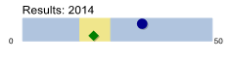
  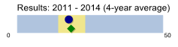
    Yr7
    Yr8
    Yr9
    Yr10
    Yr11
    Yr12
    87 %
    83 %
    82 %
    NA
    NA
    NA
  
Student Retention

Percentage of Year 7 students who remain at the school through to Year 10.

  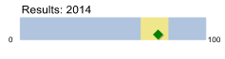
  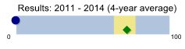
  
  Students exiting to further studies and full-time employment
  Percentage of students from Years 10 to 12 going on to further studies or full-time employment.
  Note: This measure uses data from the previous year.
  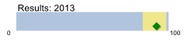
  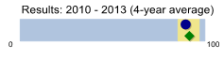
  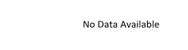

  (Secondary Year Levels)
  Performance Summary
  Wellbeing
  Student Outcomes
  School Comparison
  Students Attitudes to School
  Measures the Connectedness to School factor derived from the Attitudes to School survey completed annually by Victorian government school students in Years 5 to 12. The school's average score is reported here on a scale of 1 to 5, where 5 is the highest possible score.
  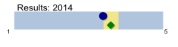
  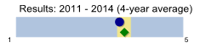

  How to read the Performance Summary
  What are student outcomes?
  Student outcomes show the achievements of students in this school in English and Mathematics. They also show results in national literacy and numeracy tests and, for secondary colleges, the Victorian Certificate of Education (VCE) examinations. They provide important information about student attendance and engagement at school.
  For secondary colleges, the Performance Summary also provides information about how many students at this school go on to further studies or full-time work after leaving school.
  You can see these results for the latest year, as well as the average of the last four years (where available).
  The Performance Summary also allows you to compare student outcomes for students at this school with the outcomes of students in all other Victorian government schools.
  What is a School Comparison?
  The School comparison is a way of comparing school performance that takes into account the different student intake characteristics of each school.
  A School comparison takes into account the school’s academic intake, the socio-economic background of students, the number of Indigenous students, the number of non-English speaking and refugee students, the number of students with a disability, and the size and location of the school.
  The School comparison measures show that most schools are doing well and are achieving results that are ‘similar’ to what we would estimate given the background characteristics of their students. Some schools are doing exceptionally well with the students they have, and have ‘higher’ performance. Some schools have ‘lower’ performance after taking into account their students’ characteristics – these schools will receive targeted support to ensure that there is improvement.
 | 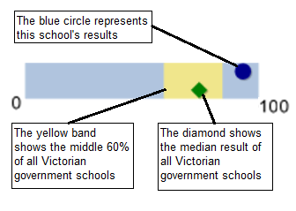
 |  |  |  |  |  |  | 
Looking at both the student outcomes and school
comparisons provides important information about what
a school is doing well and the areas that require further
improvement.

More information on school comparison performance
measures can be found at:
http://www.education.vic.gov.au/school/principals/manage
ment/pages/performreports.aspx

What is the meaning of ‘Data not available’?

For some schools, there are too few students to provide
data. For other schools, there are no students at some
levels, so school comparisons are not possible. Newly
opened schools have only the latest year of data and no
averages from previous years. The Department also
recognises the unique circumstances of Specialist, Select Entry, English Language and Community Schools where
school comparisons are not appropriate.

What is this school doing to improve?

All schools have a plan to improve outcomes for their
students. The ‘About Our School’ statement provides a
summary of this school’s improvement plan.

Additionally, NAPLAN learning gain charts are provided for each of the NAPLAN domains. These compare a student's current year NAPLAN result to the results of all ‘similar’ Victorian students (i.e. students in all sectors in the same year level who had the same NAPLAN score two years prior).

If the current year result is in the top 25% their gain level is categorised as ‘High’, the middle 50% is categorised as ‘Medium’ and the bottom 25% is categorised as ‘Low’.

 |  | 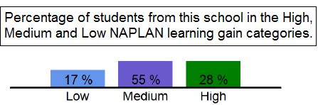

  Financial Performance and Position
  Financial Performance - Operating Statement
  Summary for the year ending 31 December, 2014
  Financial Position as at 31 December, 2014
  Revenue
  Actual
  Funds Available | Actual
  High Yield Investment Account | $201,713
  Official Account | $82,943
  Other Accounts | $22,425
  Total Funds Available | $307,081
  Student Resource Package
  $9,045,052
Government Provided DE&T Grants | $1,534,081
Government Grants Commonwealth | $44,935
Revenue Other | $129,943
Locally Raised Funds | $524,296

  Total Operating Revenue
  $11,278,307
  Expenditure
  Financial Commitments
  Operating Reserve | $79,836
  Capital - Buildings/Grounds incl SMS<12 months | $22,254
  Revenue Receipted in Advance | $28,846
  School Based Programs | $176,146
  Total Financial Commitments | $307,081
  Student Resource Package
  $9,071,132
Books & Publications | $12,448
Communication Costs | $64,769
Consumables | $283,550
Miscellaneous Expense | $599,216
Professional Development | $22,653
Property and Equipment Services | $474,313
Salaries & Allowances | $481,430
Trading & Fundraising | $55,673
Travel & Subsistence | $9,905
Utilities | $173,195

  Total Operating Expenditure
  $11,248,284
  Net Operating Surplus/-Deficit
  $30,023
  Asset Acquisitions
  $0
  Misc Expenses may include Bank Charges, Health and Personal Development, Support Services, Administration charges, Camp/Excursion costs.
  Salaries and Allowances refers to school-level payroll.
  Financial performance and position commentary
  A concerted effort by WMYC Management Team has seen a significant turnaround in the financial performance of the College in 2014. This has allowed to College to spend money on much need Capital Resources to support the delivery of the College Curriculum.

